**A CRM APPLICATION TO MANAGE THE MALL**

## 1.PROJECT OVERVIEW

The CRM application for managing the mall is an innovative solution designed to integrate all aspects of mall operations into a single, cohesive platform using Salesforce. This project aims to centralize the management of sales, customer service, and marketing activities, providing a unified solution that enhances operational efficiency and customer experience.

By leveraging the powerful features of Salesforce, this CRM application will address the specific needs of mall management, tenants, and customers. The application will feature various modules including tenant management, customer engagement, event planning, and maintenance management. Each module is tailored to streamline processes, reduce manual effort, and provide real-time insights for better decision-making.

The implementation of this CRM application will revolutionize mall management by automating routine tasks, centralizing data, and providing advanced analytics. This will enable mall management to make informed decisions, improve tenant relations, enhance customer satisfaction, and ultimately increase profitability. By integrating all aspects of mall operations into a single platform, the CRM application will provide a seamless and efficient management experience

.

## 2. OBJECTIVES

### Primary Objectives

1. **Enhance Customer Relationship Management**: Develop a robust CRM system to capture, track, and analyze customer interactions. This will enable personalized services, targeted marketing, and improved customer satisfaction.
2. **Centralize Data Management**: Implement a centralized database that consolidates all customer and tenant information, ensuring data consistency, accuracy, and easy accessibility.
3. **Automate Marketing Campaigns**: Utilize Salesforce Marketing Cloud to design, execute, and monitor automated marketing campaigns. This will help in increasing engagement, improving conversion rates, and boosting marketing ROI.
4. **Optimize Sales Processes**: Streamline the entire sales process from lead generation to deal closure. Automation of sales operations will enhance efficiency, reduce manual effort, and increase revenue.
5. **Improve Customer Service**: Leverage Salesforce Service Cloud to provide efficient and responsive customer support. Automated case management, knowledge base, and customer support tools will ensure prompt resolution of queries and issues.
6. **Facilitate Tenant Management**: Manage tenant information, lease agreements, payment schedules, and maintenance requests through a unified platform. This will enhance tenant satisfaction and retention.

### Secondary Objectives

1. **Enhance Event Planning**: Improve coordination and management of mall events, including scheduling, resource allocation, and attendance tracking.
2. **Streamline Maintenance Management**: Automate maintenance requests, track facility usage, and manage preventive maintenance schedules to ensure smooth operations.

## 3. SALESFORCE KEY FEATURES AND CONCEPTS UTILIZED

### Core Features

1. **Sales Cloud**: Provides tools for managing the entire sales process, including lead management, opportunity tracking, and sales forecasting. This feature helps in streamlining sales operations and improving revenue generation.
2. **Service Cloud**: Enhances customer service by providing tools for case management, knowledge base, and customer support automation. It ensures prompt resolution of customer queries and issues, improving customer satisfaction.
3. **Marketing Cloud**: Automates marketing efforts, including email campaigns, social media engagement, and customer journeys. This feature helps in increasing engagement, improving conversion rates, and boosting marketing ROI.
4. **Community Cloud**: Creates an interactive portal for tenants and customers to share feedback, access resources, and communicate. It enhances tenant and customer engagement, fostering a sense of community within the mall.

### Advanced Features

1. **Salesforce Einstein Analytics**: Provides AI-driven insights and advanced analytics for better decision-making and performance tracking. It enables mall management to gain actionable insights and make data-driven decisions.
2. **Custom Objects and Fields**: Allows for the creation of custom data models to meet the specific needs of mall management. This feature enables the tracking of tenant information, maintenance schedules, and other custom data points.
3. **Workflow Rules and Process Builder**: Automates business processes, such as sending notifications, updating records, and creating tasks. This feature helps in reducing manual effort and ensuring consistency in business processes.
4. **Chatter**: Facilitates real-time collaboration and communication among mall management staff. It enhances internal communication and helps in coordinating tasks and activities.

## 4. DETAILED STEPS TO SOLUTION DESIGN

1. **Requirement Gathering**: Conduct detailed discussions with mall management, tenants, and customers to identify their needs and expectations. This step involves gathering requirements, understanding pain points, and defining the scope of the project.
2. **System Design**: Develop a comprehensive architecture for the CRM system, outlining the various modules, data flow, and integration points. This step involves creating design documents, data models, and system blueprints.
3. **Customization**: Configure Salesforce features to align with the specific requirements of mall management. This involves creating custom objects, fields, and workflows to meet the unique needs of the mall.
4. **Integration**: Ensure seamless integration with existing systems such as POS, security, and tenant management software. This involves setting up integration points, data synchronization, and ensuring data consistency.
5. **Development**: Build the CRM system, including custom components and configurations. This step involves developing the system, configuring settings, and setting up user roles and permissions.
6. **Testing**: Perform thorough testing, including unit testing, integration testing, and user acceptance testing (UAT), to ensure system functionality. This step involves validating the system, identifying and fixing issues, and ensuring the system meets user requirements.
7. **Deployment**: Roll out the CRM system in phases, starting with a pilot phase to gather feedback and make adjustments before full deployment. This step involves deploying the system, monitoring its performance, and making necessary adjustments.
8. **Training and Support**: Provide comprehensive training to staff and tenants on using the CRM system. This involves creating training materials, conducting training sessions, and providing ongoing support and maintenance.

## 5. TESTING AND VALIDATION

### Testing Phases

1. **Unit Testing**: Validate individual components and functionalities to ensure they work as intended. This involves testing each component in isolation and verifying its functionality.
2. **Integration Testing**: Test the integration of various modules and systems to ensure seamless data flow and functionality. This involves testing the interactions between different components and ensuring they work together as expected.
3. **User Acceptance Testing (UAT)**: Engage end-users in testing the system to ensure it meets their needs and expectations. This involves conducting user testing sessions, gathering feedback, and making necessary adjustments.
4. **Performance Testing**: Assess the system’s performance under various loads and conditions to ensure it can handle peak usage. This involves testing the system's response time, throughput, and resource utilization.
5. **Regression Testing**: Verify that new updates and changes do not disrupt existing functionalities and workflows. This involves retesting the system after changes to ensure existing features work as expected.

### Validation Criteria

* **Accuracy**: Ensure all data and functionalities are accurate and reliable. This involves validating the correctness of data and verifying that all features work as intended.
* **Efficiency**: Confirm that the system operates efficiently, without unnecessary delays or resource consumption. This involves optimizing the system's performance and ensuring it can handle peak usage.
* **User Satisfaction**: Ensure that users find the system intuitive and effective for their needs. This involves gathering user feedback and making necessary adjustments to improve the user experience.

## 6. KEY SCENARIOS ADDRESSED BY SALESFORCE IN THE IMPLEMENTATION PROJECT

1. **Tenant Management**: Efficiently track and manage lease agreements, payment schedules, and maintenance requests. This ensures timely renewals, addresses tenant issues promptly, and enhances tenant satisfaction.
2. **Customer Engagement**: Enhance customer experience through personalized marketing campaigns, loyalty programs, and event invitations. This drives foot traffic, increases customer satisfaction, and boosts engagement.
3. **Event Management**: Coordinate and manage mall events, promotions, and sales. This involves scheduling events, allocating resources, and tracking attendance and feedback to ensure successful event management.
4. **Maintenance and Facilities Management**: Streamline maintenance requests, track facility usage, and manage preventive maintenance schedules. This ensures smooth operations, timely interventions, and enhances the overall maintenance management process.

## 7. CONCLUSION

The implementation of a CRM application on the Salesforce platform will transform mall management by providing a comprehensive, integrated solution for sales, customer service, and marketing. By centralizing data, automating processes, and leveraging advanced analytics, the CRM will enhance operational efficiency, improve tenant and customer satisfaction, and drive revenue growth. This project will serve as a benchmark for future technology-driven initiatives in mall management, setting new standards for excellence and innovation.

The CRM application will not only streamline operations but also provide a seamless and efficient management experience. By integrating all aspects of mall operations into a single platform, the CRM application will empower mall management to make informed decisions, improve strategic planning, and enhance overall efficiency. This will ultimately lead to increased profitability, tenant retention, and customer satisfaction, making the mall a preferred destination for shoppers and tenants alike.

**OUTPUT:**

**PICTURE 1:**

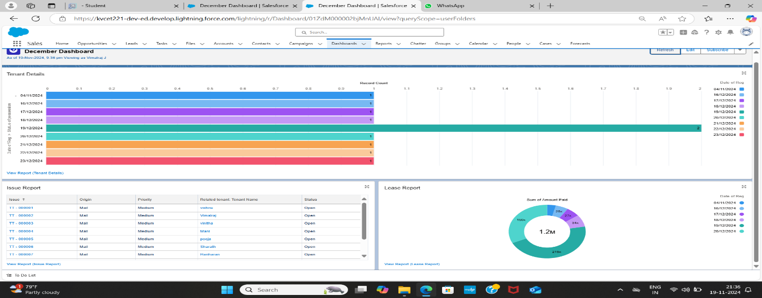

**PICTURE 2:**

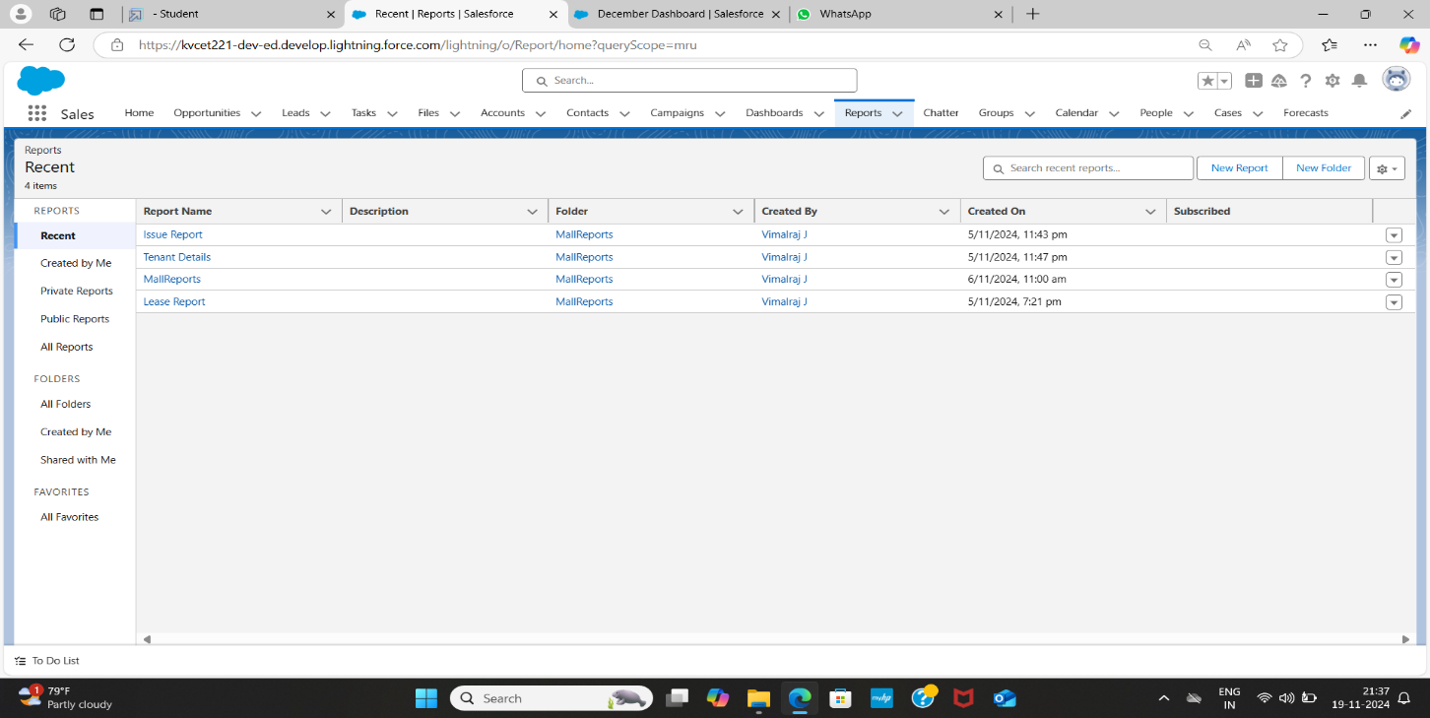

**PICTURE 3:**

